Getting Started With Jenkins

~By Krishan Rupani

Jenkins​ is a DevOps tool for Continous Integration and Delivery. It is written in Java with its plugins built for Integration purposes. It is Open Source and so available to all the developers they can collaborate easily.

Features:

* Easy Configuration
* Easy Installation
* Available Plugins
* Extensible
* Easy Distribution
* Free Open Source

Let’s get started by installing Jenkins.

In this tutorial, I will be using Windows OS.

As Jenkins is written in Java, we need to install Java. Go to this link and install JDK for your system: <https://www.oracle.com/in/java/technologies/javase/javase-jdk8-downloads.html>

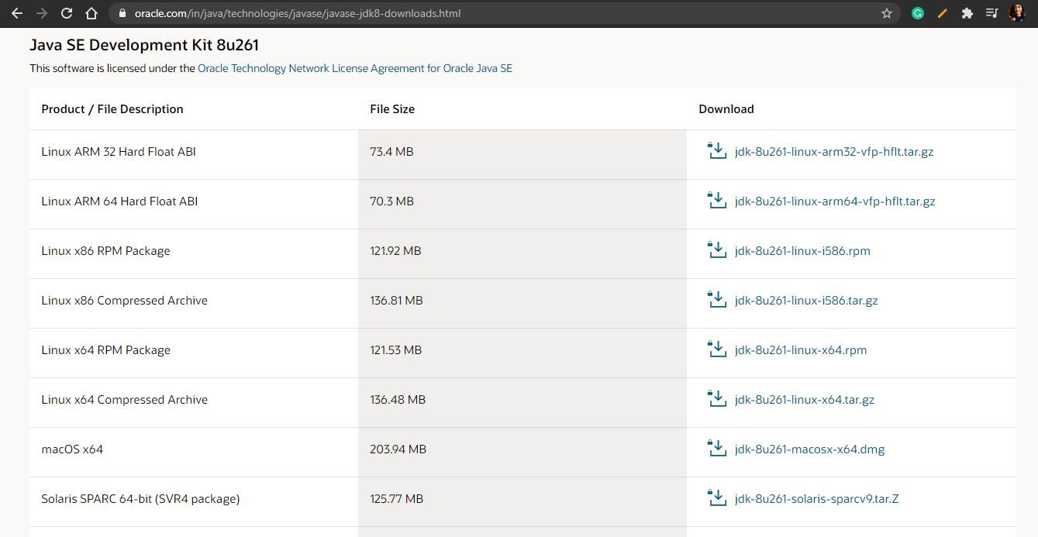

Let’s copy the location of our JDK as we will need this to set environments variables.

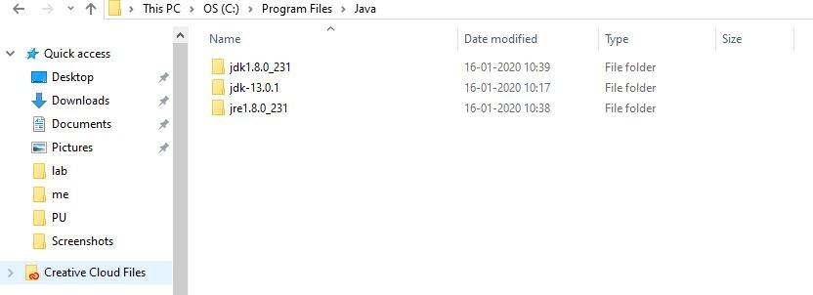

We will add variable as JAVA_HOME and the provide location of the JDK folder.

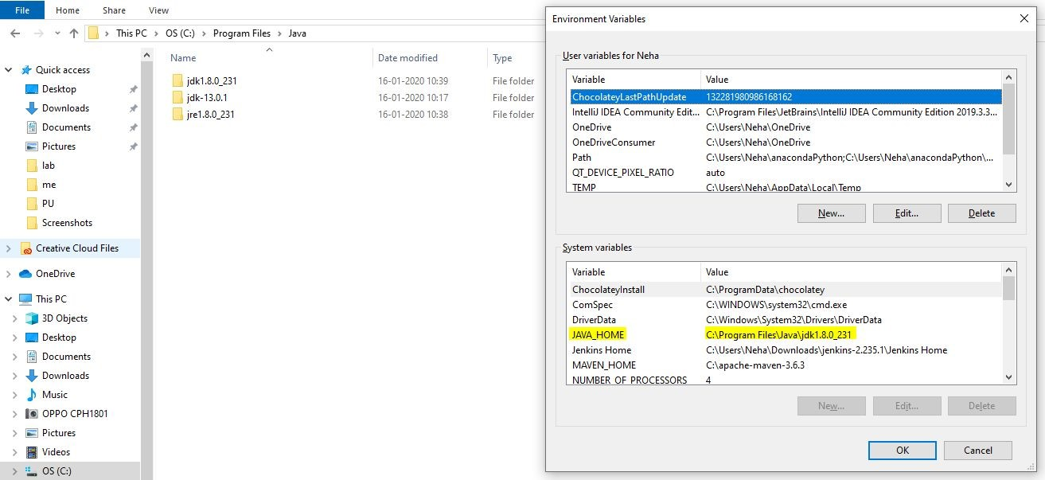

We will check if java is available by typing the command: “java -version”​

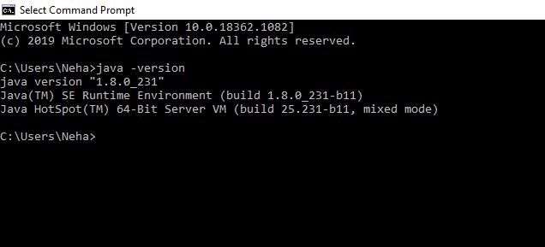

Now, let’s move and download Jenkins

<https://www.jenkins.io/download/> I have downloaded jenkins.war file​

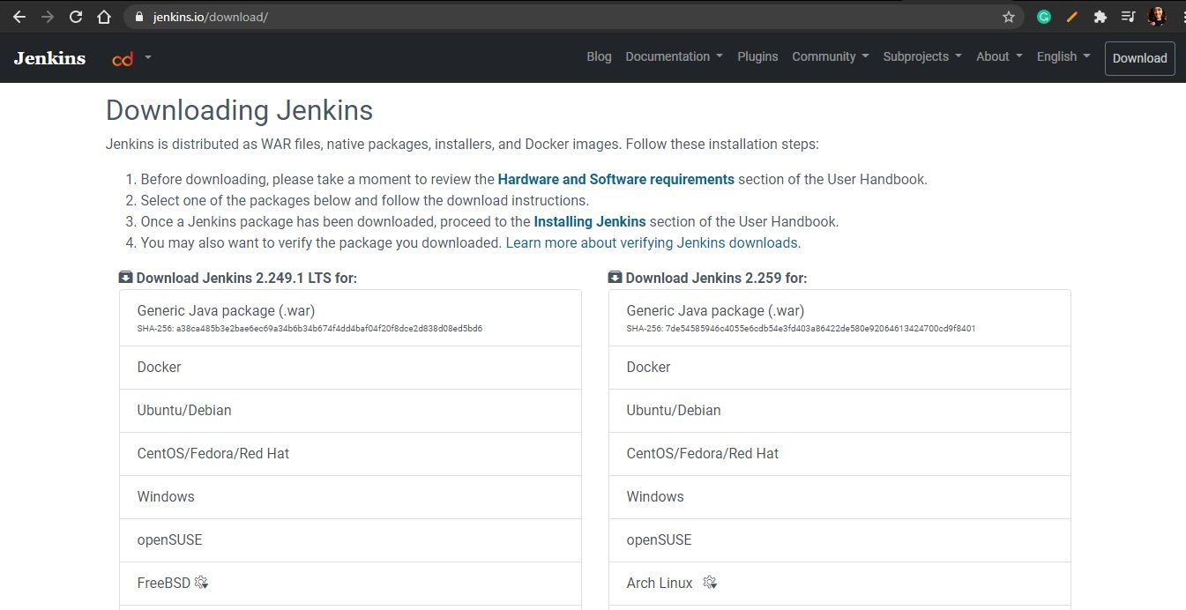

Now, you can see that jenkins.war file has been downloaded.



Now, we will run Jenkins by command: “java -jar jenkins.war”​

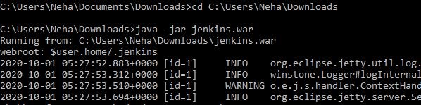

Move to your browser and type “localhost:8080”. ​ You will see a screen like this. Here, the​ password asked is available in the location provided in your local machine. Just go to that location and paste the password here.

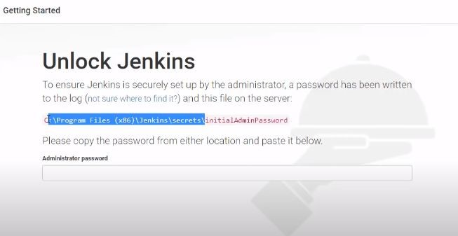

Click on install suggested Plugins

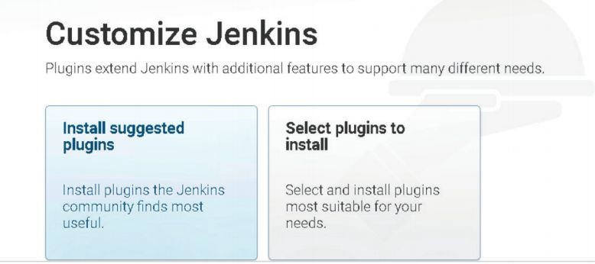

Jenkins will download all required plugins.

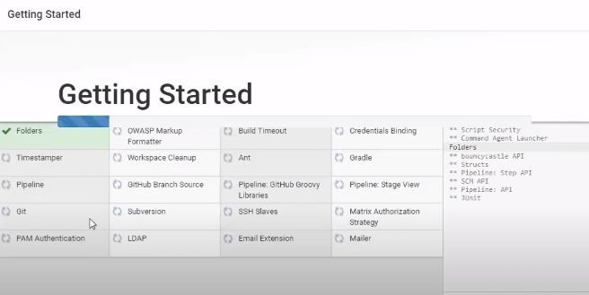

Reset your credentials.

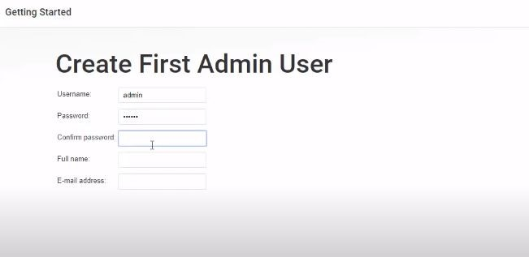

Now, you are ready to play with Jenkins.

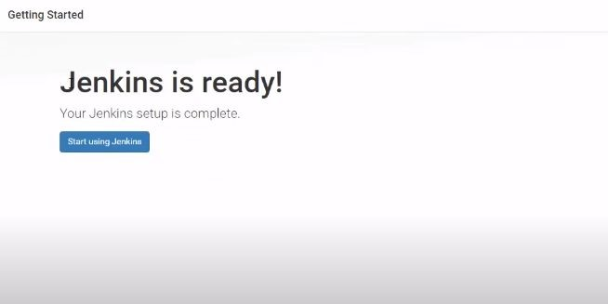

Enter Your credentials here to console.

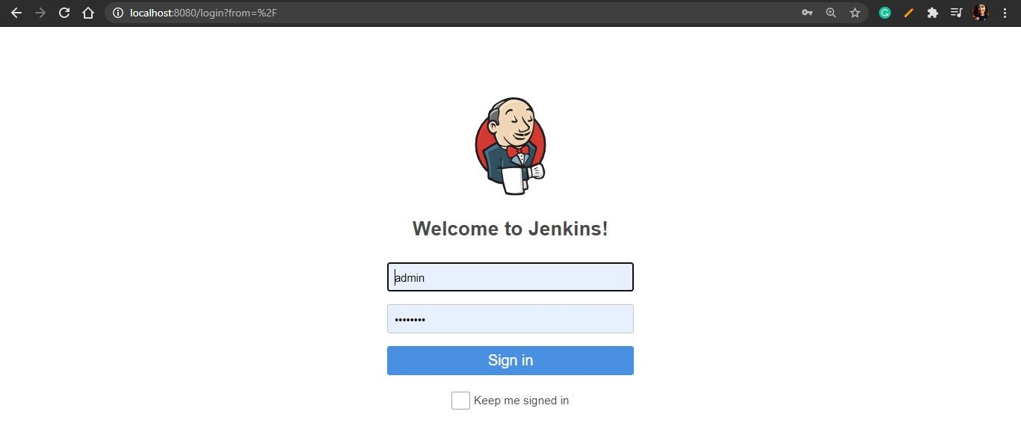

You will be having no projects for the first time.

On the left side you can see various features of Jenkins, eg; New Item, People, Build History, Manage Jenkins, etc.

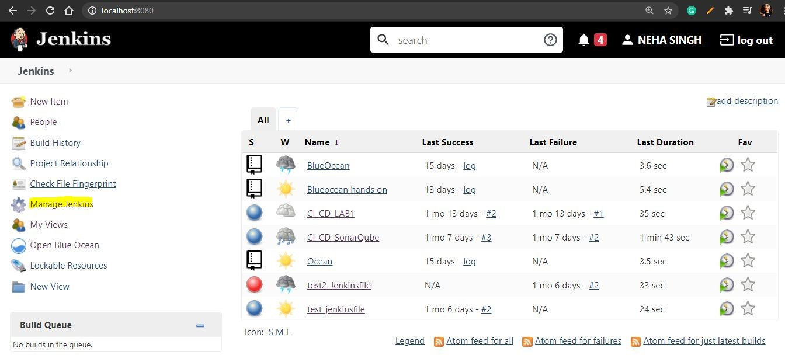

Let’s have a walkthrough Jenkins and its features.

In new items, you can see various type of projects can be made in Jenkins.

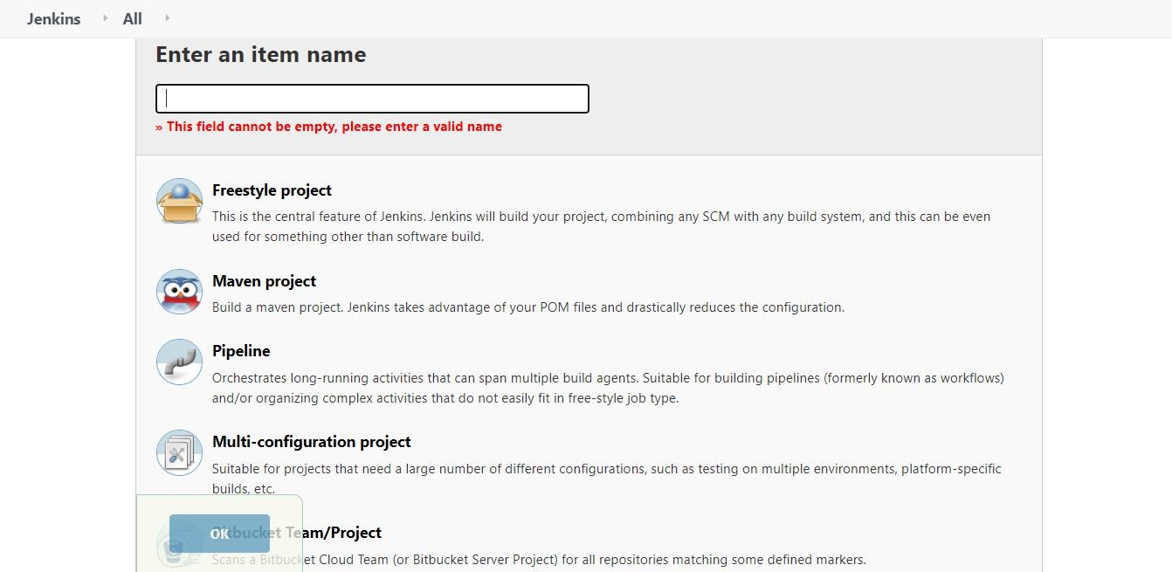

Inside people, you can see all the members you have created and edit their accessibility.

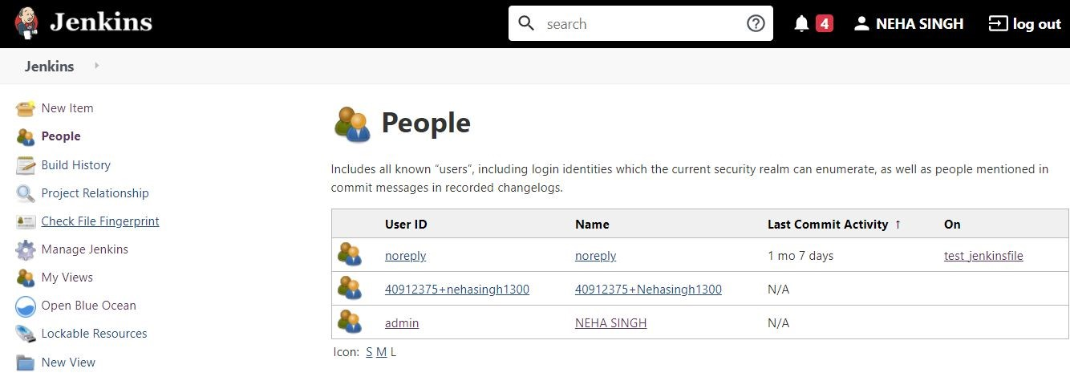

Inside Build History, you can check all the build done by you and their sta

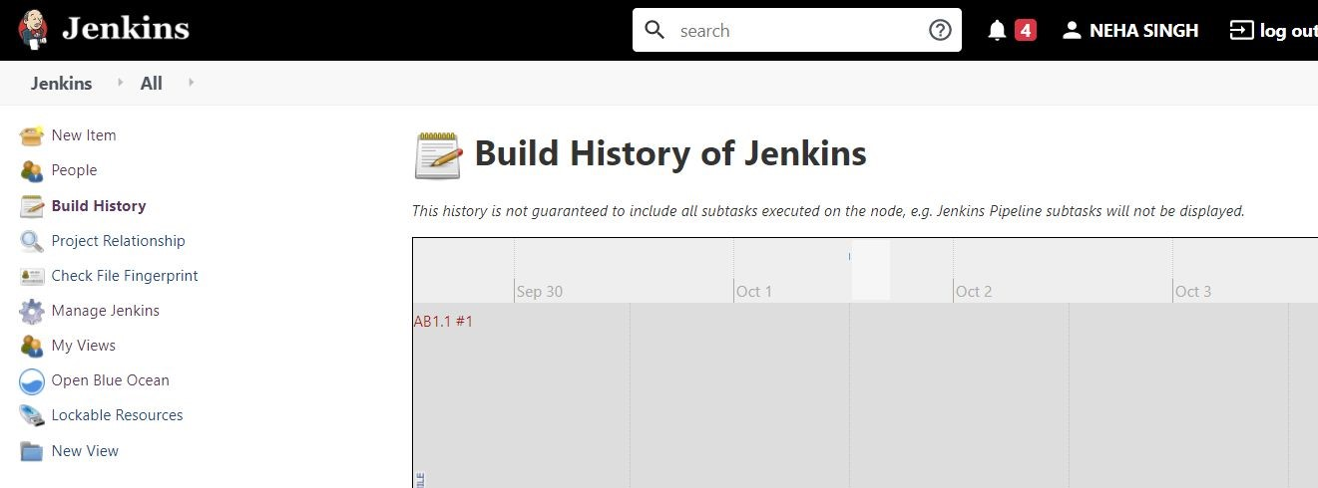

Inside, Manage Jenkins you can check for System Configuration and security

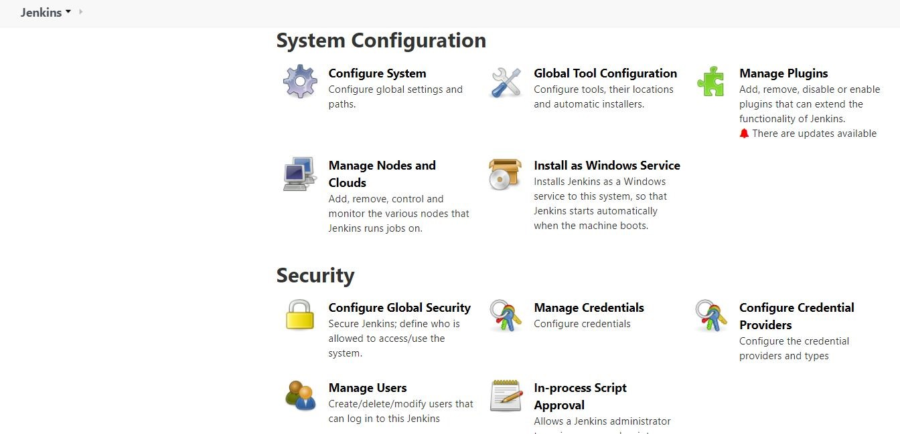

In system configuration, inside plugins, you can check for various plugins

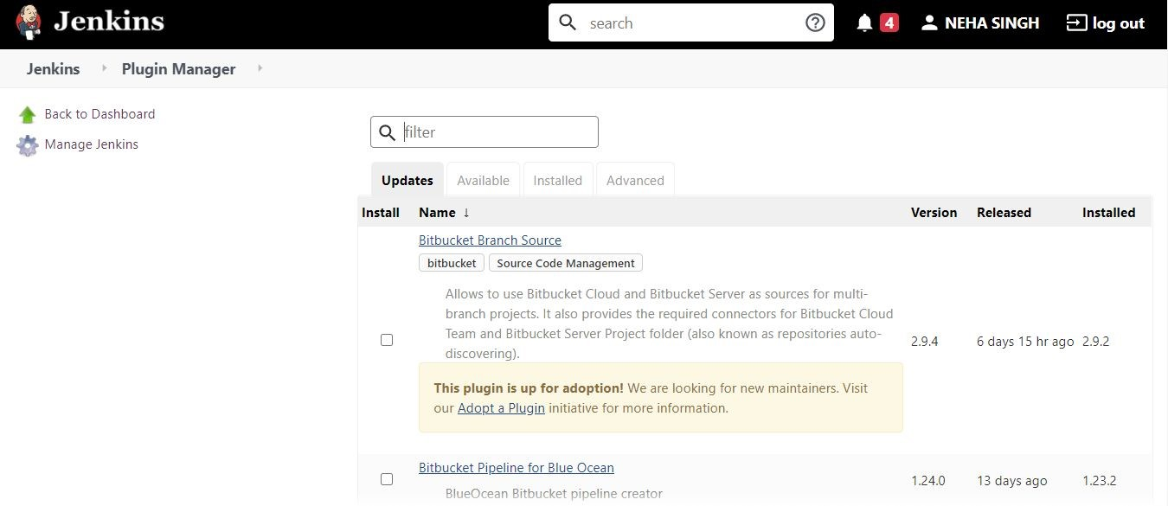

Status Information, Troubleshooting, and Tools and Actions.

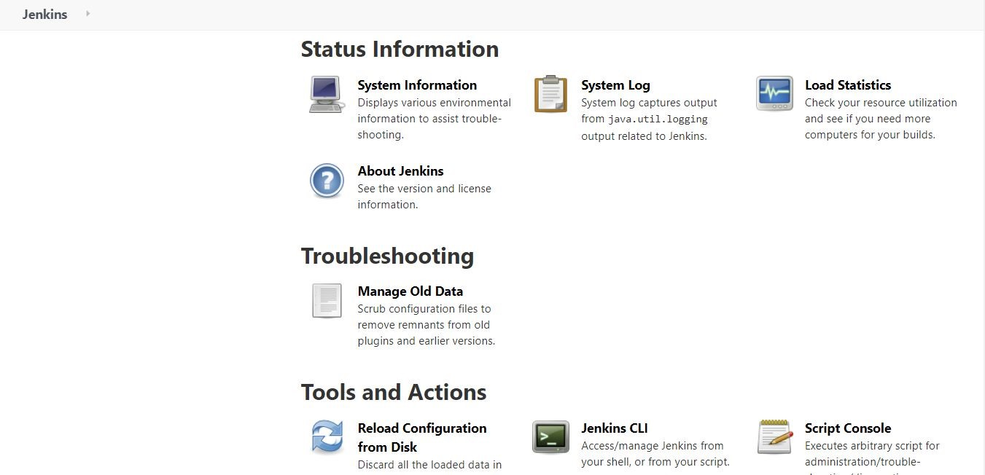

Simple Project

In this project, we will just make Jenkins open cmd and run an echo command with the message of Simple Project 1 and build it.

Click on New Item >> Name the project as “Simple Project 1” >> take the project as Freestyle Project.

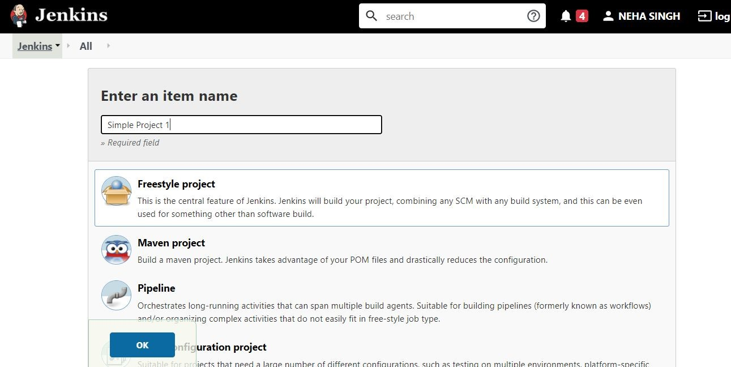

You can configure the project:

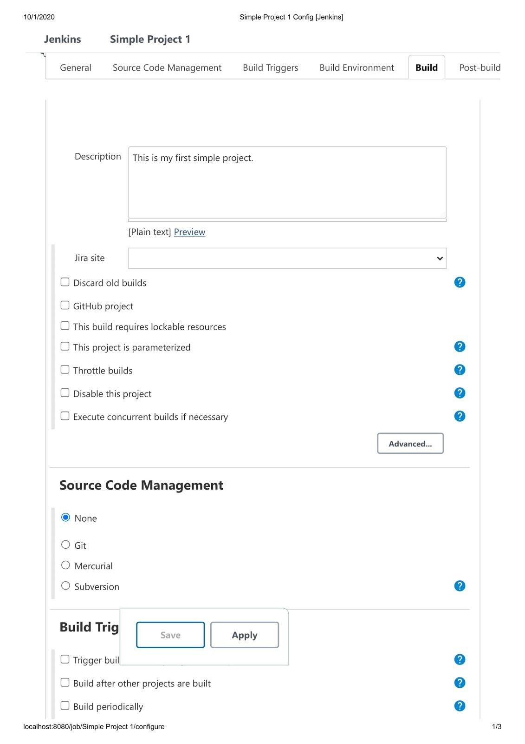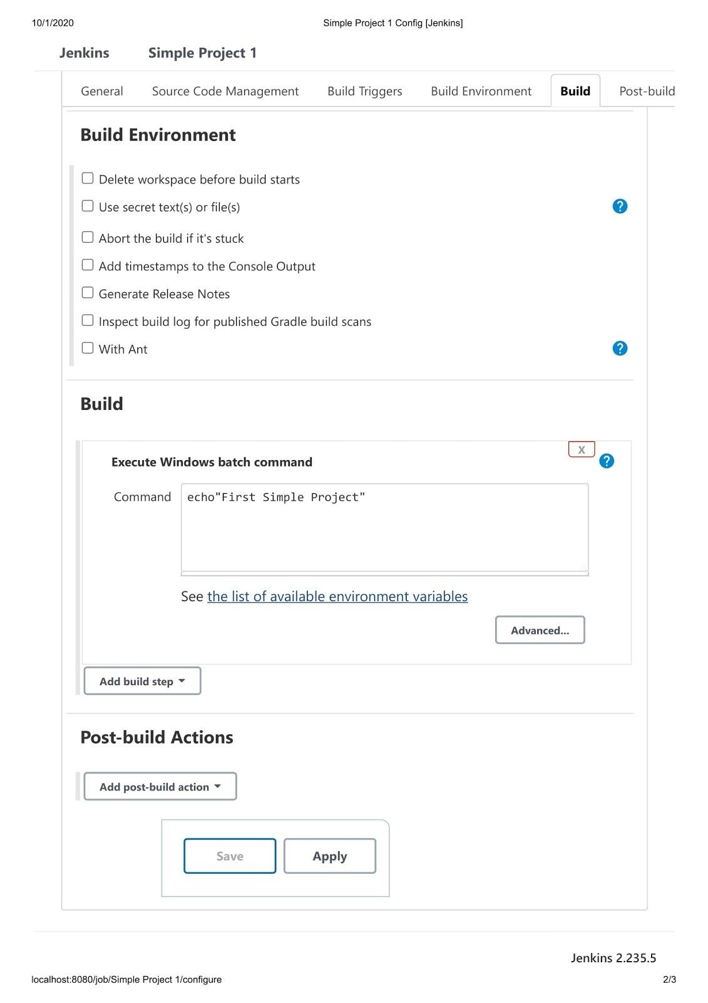

You can build the project by clicking the Build Now and then it will start building the project automatically.

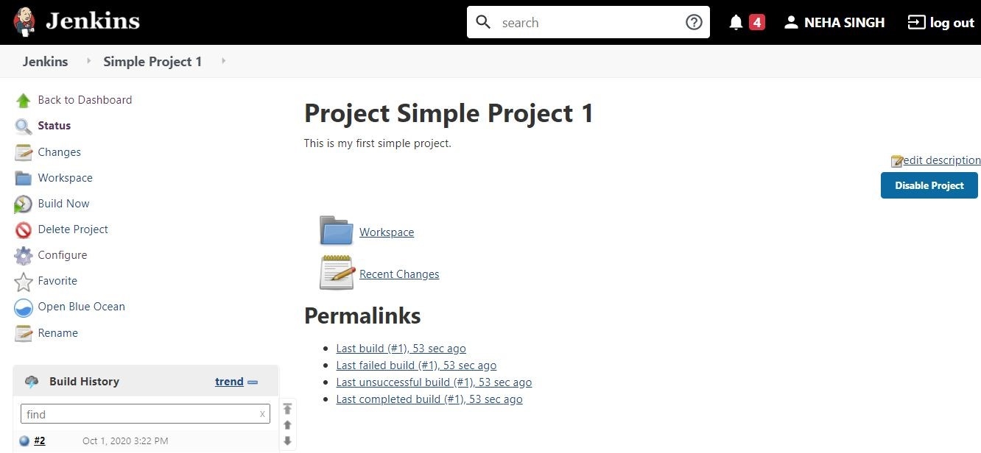

You can see that project has built easily.

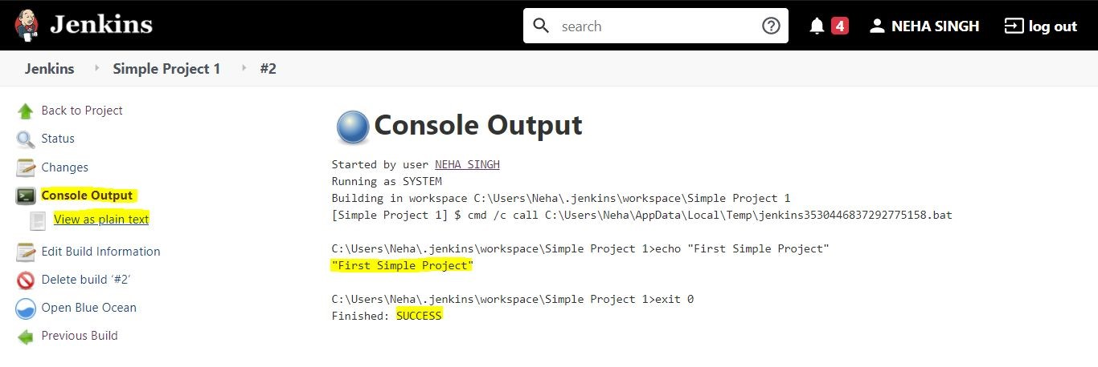

That’s all! For this module. We will continue learning more cool features of Jenkins in next module.